Sample paper- 3
Class XIth
Biology
Time: 3 hrs MM: 70
General instructions:
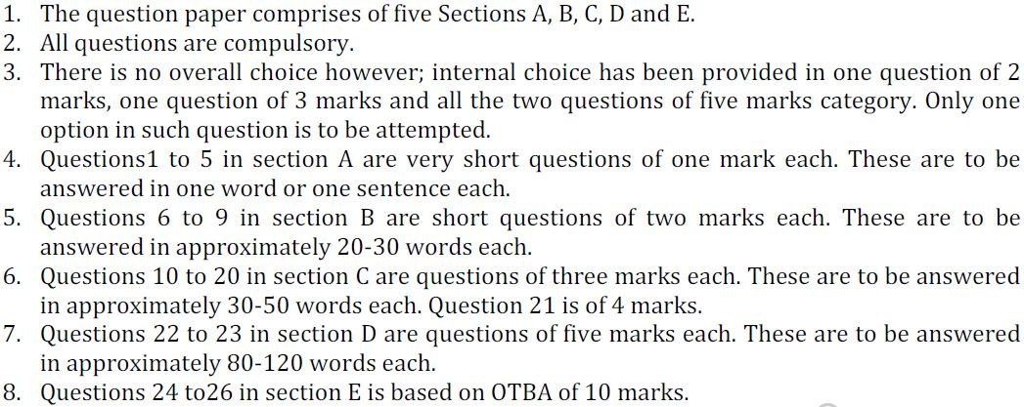

Section A
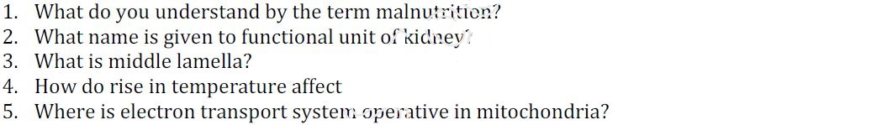

Section B
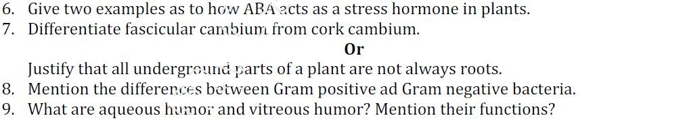
Section C
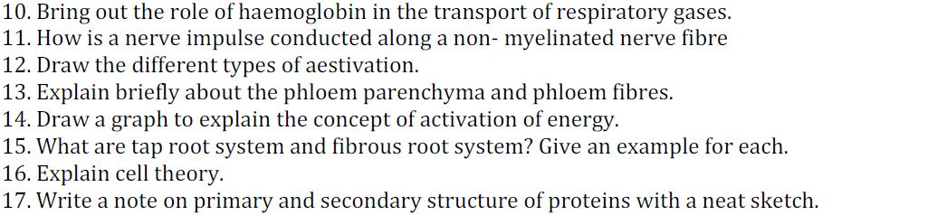

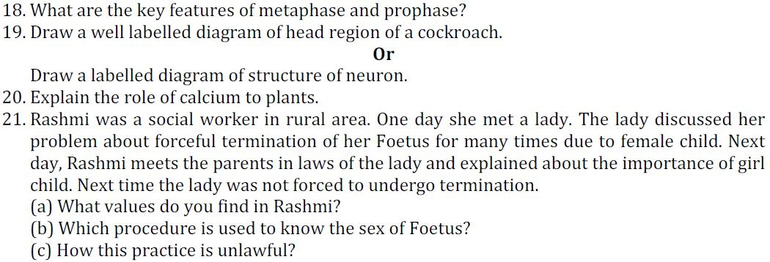
Section D
22. Explain the structure of monocot stem with the help of diagram.
Or
Explain C3 cycle in plants.
23. Write down the characteristics features of kingdom-fungi.
Or
Explain mode of sexual reproduction in different classes.
Section E

